# 2022 Elections

August 2 – State Primary Election

November 8 – State General Election

Polls are open from 7 AM-8 PM on Election Days

Absentee Ballots may be obtained by contacting the Clerk’s office at 517 596-8400

Check website or Facebook for other ballot issues

# Holiday Schedule (Office closed)

7/4/22 July 4th Holiday

9/5/22 Labor Day

10/10/22 Columbus Day

11/11/22 Veteran’s Day

11/24/22-11/25/22 Thanksgiving Holiday

12/23/22-12/26/22 Christmas Holiday

12/30/22-1/2/23 New Year’s Holiday

1/16/23 Martin Luther King’s Birthday

2/20/23 President’s Day

5/29/23 Memorial Day

6/19/23 Juneteenth

# Waterloo Township Board

**Supervisor** Office 596-8200

Doug Lance Cell 517-917-4575

Email: [supervisor@waterlootwpmi.com](mailto:supervisor@waterlootwpmi.com)

**Clerk** Office 596-8400

Janice Kitley (Notary) Cell 517-231-7601

Email: [clerk@waterlootwpmi.com](mailto:clerk@waterlootwpmi.com)

**Deputy Clerk**

Mary Gibbons

Email: [deputyclerk@waterlootwpmi.com](mailto:deputyclerk@waterlootwpmi.com)

**Treasurer** Office 596-8300

Wendy Walz

Email: wwalz@waterlootwpmi.com

**Deputy Treasurer**

Judy Boomer

Email: [deputytreasurer@waterlootwpmi.com](mailto:deputytreasurer@waterlootwpmi.com)

**Trustee**

Position vacant at the time of this printing

**Trustee**

Joshua McAlister

Email: jmcalister@waterlootwpmi.com

# Building Department

**Administrative Assistant / Building Clerk** Missy Hess Office: 517-596-8200

# Email: buildingdept@waterlootwpmi.com

**Building Inspector / Code Official** Rohn Tripp Phone: 517-206-7043

**Electrical Inspector**

Keith King Phone: 517-206-2070

**Plumbing/Mechanical Inspector**

Tim Basore Phone: 517-623-6257

**Zoning Administrator**

Rohn Tripp Office: 517-596-8200

Email: [rtripp@waterlootwpmi.com](mailto:rtripp@waterlootwpmi.com)

Office Hours: Mondays 9:00am-12:00pm

**Zoning Enforcement**

John Beck

Email: [Jbeck_1968@yahoo.com](mailto:Jbeck_1968@yahoo.com)

For immediate Zoning Enforcement Assistance, please call the Township Office

# Assessor

Heidi Roenicke Office: 517-596-8200

Email: assessor@waterlootwpmi.com

Office Hours: Mondays 9:00am-12:00pm

# Monthly Meetings

**Township Board –**

7 PM Fourth Tuesday of each Month

**Planning Commission –**

7 PM Third Tuesday of each Month

**Zoning Board of Appeals –**

January and July

7 PM Third Thursday of the Month

**Parks & Recreation –**

9:30 AM Second Tuesday of each Month

**Meeting dates subject to change. Confirm Meeting times by going to the website of FaceBook page**

**Emergency / Police Service**

**Please Call 911**

# waterloo-transparent-bg.png

# 2022-2023 Information

# 9773 Mt. Hope Road

# Munith, MI 49259

# NEW Office Hours

# Monday, Tuesday, & Thursdays

# 9 AM – 1 PM

# Wednesdays 1-5 PM

# (Clerk & Treasurer available additional hours by appointment)

# “LISTENING TO RESIDENTS ~

# FOCUSING ON SOLUTIONS”

# Office Numbers

# 517-596-8200 Building Clerk

# 517-596-8300 Township Treasurer

# 517-596-8400 Township Clerk

# 517-596-8600 Fax

# [www.waterlootwpmi.com](http://www.waterlootwpmi.com)

**Look for our new and improved website coming soon!!!**

# Hall Rental

The Township Hall is available to **Waterloo Township Residents** to rent for your events. You can also rent our tables and chairs. Please contact the Township Clerk at 517-596-8400, or our website for details, applications and fee schedule.

# Trash Collection Day for Residents

**We are having another household collection day on Saturday, September 17, 2022, from 11 AM-3 PM!** We will also be collecting scrap metal, and tires. Bring your junk. This is not for daily household garbage and we cannot take tractor tires.

**Volunteers needed to assist unloading vehicles**

**Proof of residency in Waterloo Township required**

# Burn Permits

Burn Permits can be completed at our office.

* Burn Permits can be obtained, at no cost, Monday – Thursday in our office during regular business hours, on our website, by calling our main office at 517-596-8200, or by calling SAESA Fire at 517-851-7241.
* Burn Permits cannot be obtained on weekends.

The burn permit must be dropped off or called in to the office 1 day prior to burning for approval.

* Burning can take place Monday – Sunday from dawn to dusk unless otherwise notified.
* ONLY yard debris can be burned.
* NO burning of construction material.

**Various applications and documents can be found and completed using our website.** Documents requiring signatures must still be completed and returned after printing.

**We will soon be able to take payments by credit card for property taxes and building permits. Contact the office to check on the status.**

Check out the website for other useful information and for updates.

**Parks & Recreation News**

We have a ½ mile closed loop Footpath. It’s a safe and beautiful place for you to bring your friends (including the 4-legged ones). We also have heard that it is a great place to find those Pokemon characters.

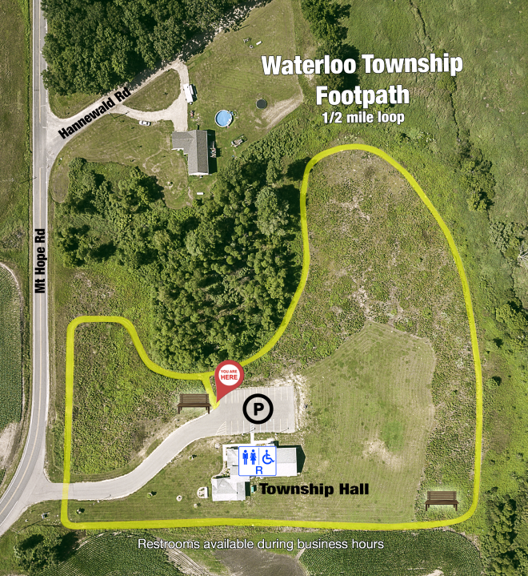

**2022 Projects** for Waterloo Township Parks & Recreation include creating Rain Garden(s) for the Footpath, plant identifiers, and a few other surprises for you as you walk around this beautiful place.

Interested in having a plant exchange? Farmers Market? Join the Parks & Rec Committee and/or submit your ideas!

**Exercise Classes at Waterloo Town Hall**

Make new friends, meet your neighbors! Join area Seniors Monday, Wednesday, & Friday mornings from 9:30 AM – 10:30 AM for fitness fun! Only $2.

Exercise class ideas? Contact us!

**Little Free Library**

Need something to read? Have reading materials to share? Stop by the Township and grab a book, or leave one! There is also a Free Library at Munith Community Park.

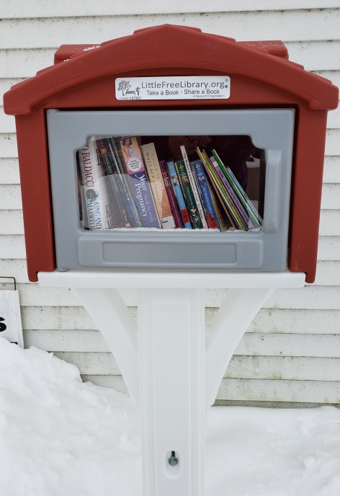

[www.waterlootwpmi.com](http://www.waterlootwpmi.com)

**New and improved website**

**coming soon!!!**

# Facebook clip art images illustrations photos